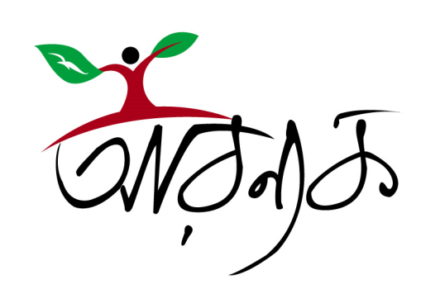 Organizational Profile
Arannayk Foundation
Bangladesh
For updates see: www.arannayk.org
Mission
Arannayk's mission is to facilitate the conservation, protection, restoration and sustainable use and management of tropical forests in Bangladesh, which provide a wide range of benefits to humankind. Its key objectives are the following:
• Dedicated to, and a key player in successfully promoting and accomplishing activities that support tropical forest conservation and biodiversity protection.
• To develop conservation partnership among the NGOs, the Government and the private sector concerning forest conservation on privately owned or leased tea estates.
• To Demonstrate that conservation can provide a sustainable alternative to the present sources of incomes and values generated from the exploitation of natural tropical forests.
• To generate sufficient complimentary funding in order to provide financial grants to qualified organizations engaged in activities aimed at conservation, protection, restoration and management of tropical forest and biodiversity assets of Bangladesh .
• To facilitate capacity development of stakeholders to ensure sustainable alternative income and employment opportunities for local communities particularly for the poor whose lives depend on natural resources.
Operations
The Arannayk Foundation will serve as a catalyst to the protection and sustainability of forest biodiversity in Bangladesh. It will adopt the ecosystem approach and consider the entire range of possible goods and services in order to optimize the mix of benefits for a given ecosystem.
The foundation will provide financial grants or other support to qualified organizations or entities, as listed below, engaged in activities aimed at conserving, protecting, maintaining and/or restoring tropical forest and biodiversity assets of Bangladesh:
(a) Non-government, environmental, developmental, educational and indigenous people's organization(s) and such other related organization(s) active in Bangladesh;
(b) Scientific, academic and professional organization(s) related to forests;
(c) Other appropriate forest related entities active in Bangladesh;
(d) In exceptional circumstances, the Government of Bangladesh, its departments and organizations.
The foundation will coordinate its project related activities and provide the needed technical and financial support to partner implementing NGOs, community based organizations and the private sector. Moreover, it will monitor the progress of all its supported programs. Forward looking assessments will be made incorporating the lessons learned and experiences gathered by the intervention programs.
Partners
The Arannayk Foundation will work with a wide range of public, NGO and private sector partners. NGO partners, community based organizations and the private sector are the main target groups. The Forest Department, Bangladesh Forest Research Institute and other key governmental organizations and the private sector including herbal companies, tea estate and eco-tours operators are possible and potential partners.
Resources
Funds will be generated through endowment. The Arannayk Foundation mandate authorizes the management to mobilize resources in the form of grants, loans and contributions from a wide variety of sources including international donors, multinational companies, the Government of Bangladesh, private individuals and organizations.
Board of Directors
List of current Board members

