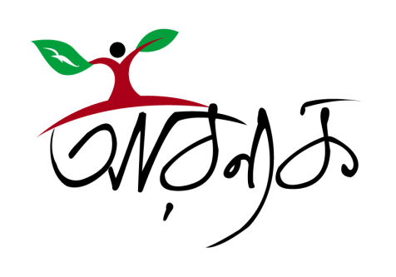 Call for Proposals
Arannayk Foundation
Bangladesh
2009 For updates see: www.arannayk.org
Arannayk Foundation (AF) – the Bangladesh Tropical Forest Conservation Foundation is seeking project proposals from eligible organizations and institutions of Bangladesh for the following program areas:
- Community-based conservation of forest resources in the Chittagong Hill Tracts
- Conservation and restoration of Hijal-Koroch forests in the Haor areas of Bangladesh
For each program area mentioned above, Arannayk Foundation may fund (as grant) multiple projects which will be selected through comparative evaluation of the proposals and the relevant experience and competence of the proponent organizations. The evaluation will be done by an independent evaluation committee using a predefined tool, PPET, which is posted at the Arannayk Foundation’s website, www.arannayk.org/ppet.php.
The duration of a proposed project should not exceed 3 years. The upper limit of the budget for a 3-year project is BDT 6,000,000.00 (taka six million only) and proportionately lower for shorter duration projects. Preference will be given to proposals that include cost-sharing by the proponent or an ensured counterpart contribution from a third source.
Although AF will consider multi-year projects, it will award funds (grant) on a yearly basis. Continuation of funding support is contingent on the evaluation of outputs for the current project period.
Who can apply?
The following types of organization and institutions are eligible for the Arannayk Foundation grants:
- Non-governmental, environmental, developmental, educational and indigenous peoples' organizations and such other related organizations active in Bangladesh
- Scientific, educational and professional organizations related to forests
- Other appropriate forest related entities active in Bangladesh
- In exceptional circumstances, the Government of Bangladesh, its departments and organizations
The applying entities must have qualified and experienced staff in the permanent set up of the organization to organize and steer the project implementation process and proven capacity and experience in implementing similar projects. Consortia involving more than two organizations will not be preferred. Preference will be given to those NGOs having well equipped office (headquarter, regional or field office) within the project Upazila/district.
Any entity will not be eligible for more than two Arannayk Foundation grants in a year although there is no limit to the number of projects an entity can apply for within a year. For the current recipients of Arannayk Foundation grants, approval of a new project is contingent upon satisfactory delivery of results of the current project.
How to apply?
The guidelines and prescribed formats for the submission of the project proposal and the organizational profile may be downloaded from Arannayk Foundation’s website, www.arannayk.org or a compact disk containing electronic copies of the same may be collected from the Arannayk Foundation office.
The project proposals should be submitted in sealed envelops, marked with the name of the ‘Program Area’ applied for, to the Arannayk Foundation office at House No. 68, Road No. 1, Block I, Banani, Dhaka -1213, by August 14, 2008.
Arannayk Foundation reserves the right to cancel the whole process or to reject all or any application without assigning any reason

